Application of Schrödinger's Wave Equation (3)
A more complex but important application of the Equation is in giving us a concept of band theory:
A crystal consists of many atoms in a periodic array. In one dimension:

We can simplify this to a series of square potential wells (called the Kronig-Penney model)

We can write the Schrödinger Equation as 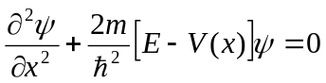
And define V=V₀ in the barriers and V=0 in the wells.
The solution to such a problem must be PERIODIC. We use a Bloch function 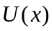 which varies with the same periodicity at the atom spacing (or lattice), a
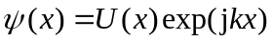 where 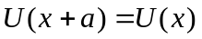
This can be solved if we apply the continuity boundary conditions discussed for finite barriers above. If we also then make the assumptions that w (the width of the wells in the structure) tends to zero, V₀ tends to infinity while the product wV₀ remains constant then we can get electron energy values where
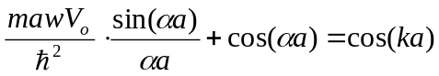, where 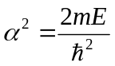.

Aside: Note on the Free Electron Model
Before discussing this further let us consider the situation for a free electron. In this case we can go back to the De Broglie relationship:
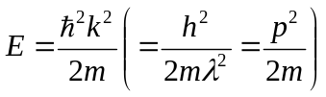
(This is also the result in the Kronig-Penney model when V₀ =0)
Note here also that k and p are directly related by a constant of proportionality: 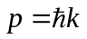. For this reason when people plot a function against k, this is called plotting against momentum.
For a free-electron we have the situation that if we plot momentum on the x-axis and Energy on the y-axis we will have a parabola. Now if we differentiate the function, E with respect to momentum twice then note that 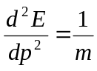. So from the double derivative we can obtain the mass of an electron.

If V₀ is not equal to 0 as in then the situation becomes more complex. We can show that be comparing the two sides of the equation, by plotting them graphically, that we can only get solutions when the left hand side takes a value between 0 and 1.

The allowed solutions represent regions where the electron can propagate freely around the crystal. In the forbidden regions the electron wavelength becomes similar to that of the spacing between the atoms. At such wavelengths one starts to get reflection of the waves, in much the same way as a multilayer coating can enhance the reflection of light.
The regions where the reflection is strong are where 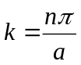 (or where 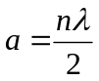). Where the wave is reflected the propagation of electron waves becomes forbidden and we have a standing wave. We can draw this on an E-k diagram (a plot of Energy against wavenumber)
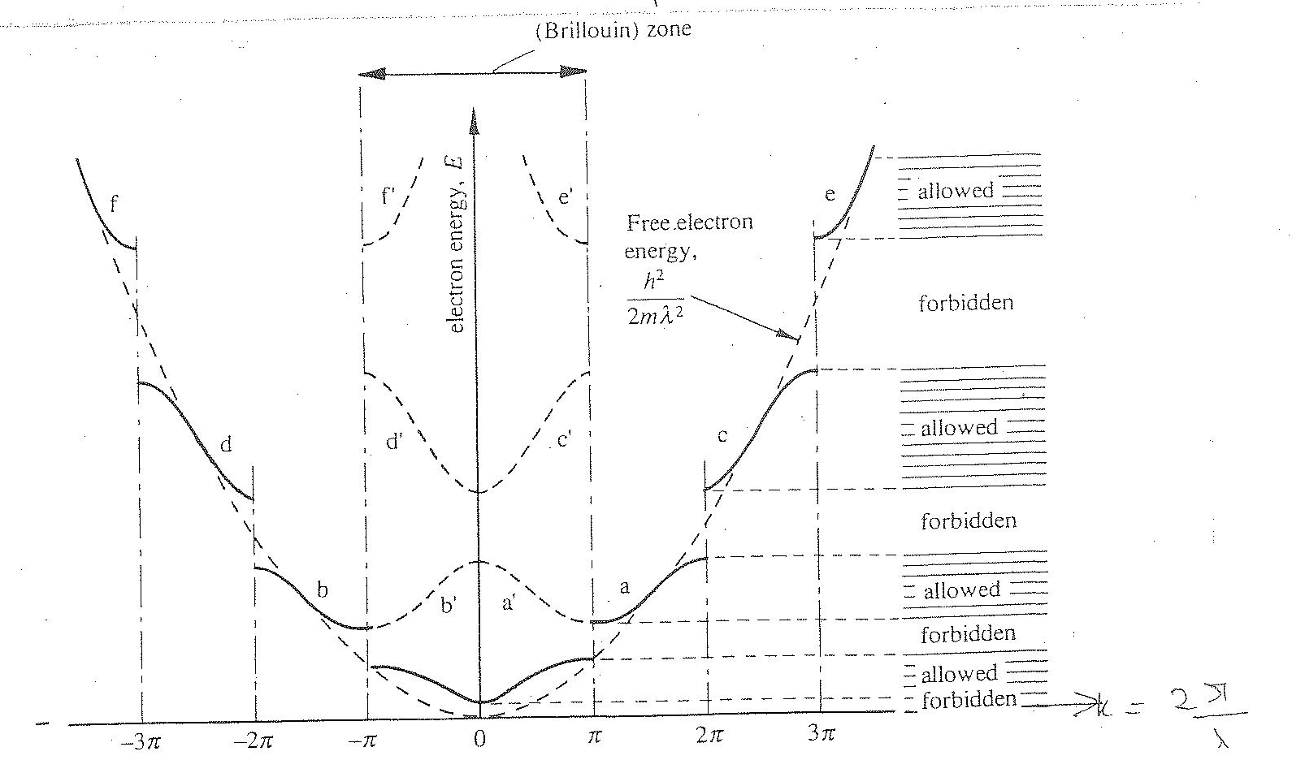

On this graph there are now regions, or bands, of allowed energies and forbidden energies, giving us a band structure as we discussed more qualitatively above.
It is found that by making V₀ progressively larger in our equation we can increase the forbidden band regions - which is the equivalent of saying that if we increase the bond strength we can increase the bandgap. This is a good general rule.
Another key point that this analysis shows is that in the allowed regions the electrons can propagrate without being scattered. This means that a perfect crystal does not cause the electrons to scatter, (collide with atoms and loose their drift velocity). Scattering is caused by "defects" in the crystal structure, such as impurities. At room temperature there are vibrational waves in the crystal, called phonons that do most of the scattering.)
Let us take the derivatives of the Band Structure and plot it graphically:
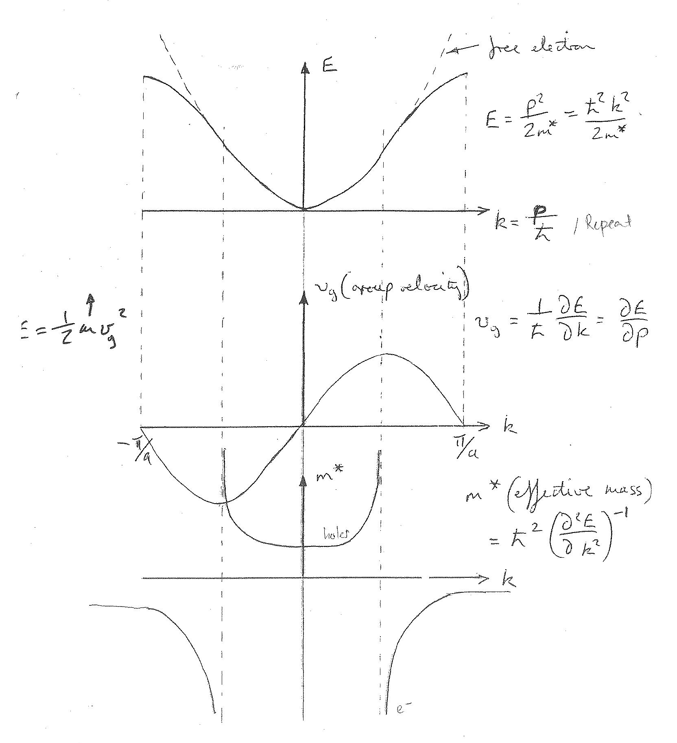
Note that the single derivative can equate to the group velocity of the electron. Note that the electron wave group velocity goes to zero at k=π/a which means that the wave is a standing wave.
For the double derivative we get the effective mass. Note that in the band centre the effective mass is nearly constant, but that it goes off to infinity in the middle of the band. At the edges the value starts to become more constant again, but the sign is inverted: the effective mass is negative - or actually positive for a hole!!

Real Band Structure
The band structure in one dimension has been discussed above. However crystals are actually three dimensional. The derivation of their band structure is actually therefore much more complex, although the same mathematical principles apply. The real Band structure shows many peaks and troughs but the key point is that usually the minimum of the conduction band and maximum of the valence band are very close to parabolic in shape. This allows us to define an effective mass for both electrons moving in the conduction band and holes in the valence band.
There is usually more than one minimum in the conduction band.
High Energy electrons can jump from one of these minima to another, which is many devices has a negative effect, but in some devices leads to an inherently useful behaviour.
The lowest conduction band minimum and valence band maximum also do not necessarily need to lie directly above each other in a plot of energy against momentum. This is actually the case in silicon and germanium. These materials are called INDIRECT bandgap semiconductors.
This also has consequences for devices, and especially optoelectronic devices. Photons (or light) has relatively little momentum compared to its energy, and in ANY interaction Energy and Momentum MUST be conserved.
In such indirect gap semiconductors in order for a an electron to fall from the conduction band to the valence band by the emission of a photon it needs the help of a phonon, which has significant momentum, to obtain conservation. This interaction is not all that probable so such semiconductors are poor emitters of light.
This is in contrast to direct bandgap semiconductors where the momentum state of the conduction band minimum and valence band maximum are the same, and photons can be readily emitted by electrons falling to the valence band.
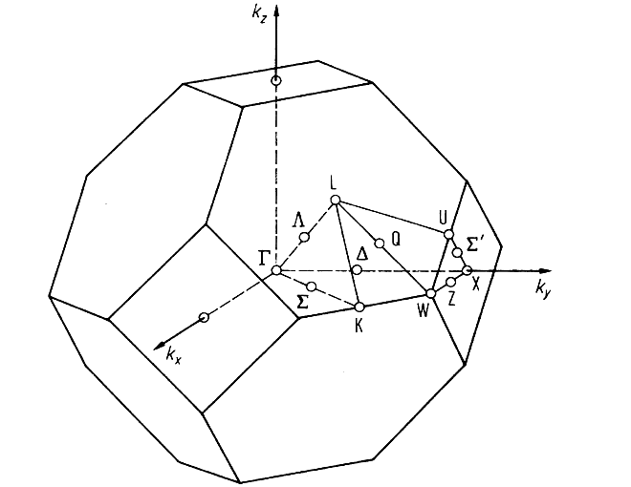
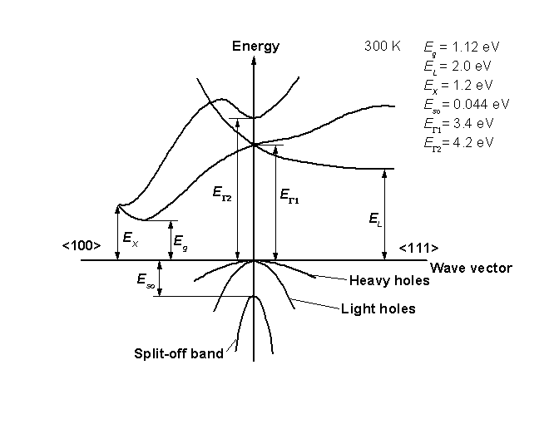
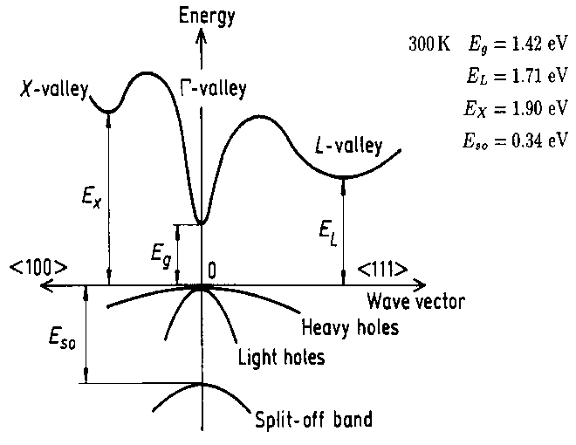
Silicon Bandstructure
Zinc Blende Lattice in Reciprocal Space (or k-space)
GaAs Bandstructure

All Figures taken from Ioffe Properties of Semiconductors website: http://www.ioffe.ru/SVA/NSM/Semicond/index.html

